Let's analyse which variables have a stronger impact on customer churn and clustering results. By comparing how each variable differs across clusters and relates to churn behaviour, we can identify the most important features and distinguish them from less useful ones.

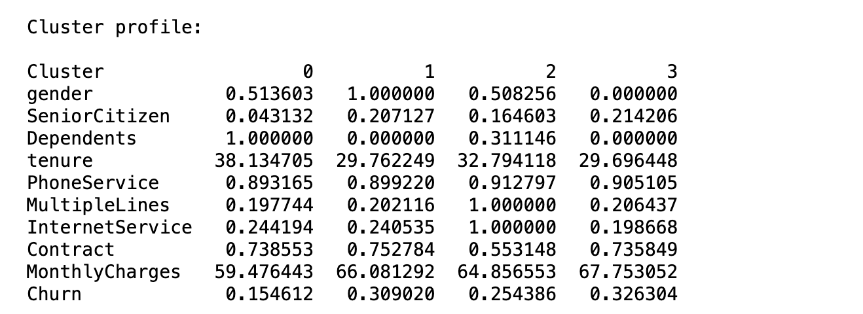
Gender is not important because it does not show meaningful differences between clusters or relate to churn.


SeniorCitizen is not important because it shows little variation across clusters and has minimal impact on churn.


Dependents is moderately important because customers with dependents tend to be more stable, but its impact is not as strong as the core variables.


Tenure is important because it clearly distinguishes customer groups and strongly relates to churn, as customers with shorter tenure are more likely to leave.


PhoneService is not important because most customers have the same value, providing little information for clustering.


MultipleLines is not important because it overlaps with other service variables and does not significantly improve clustering results.

InternetService is moderately useful as it reflects service type, but it does not significantly differentiate churn across clusters.

Contract is important because it reflects customer commitment, with shorter contracts leading to higher churn risk.

MonthlyCharges is important because higher charges are associated with higher churn, and it shows clear differences across clusters.



Cluster 0 represents long-term customers with lower monthly charges and a higher proportion of dependents, resulting in the lowest churn rate of 15.5%.
Cluster 1 and Cluster 3 consist of customers with shorter tenure and higher monthly charges, leading to significantly higher churn rates. Cluster 1 has a churn rate of 30.9%, while Cluster 3 shows the highest churn rate of 32.6%, indicating the highest churn risk.
Cluster 2 represents a moderate segment with average tenure and service usage, resulting in a moderate churn rate of 25.4%.
Overall, the analysis indicates that customers with shorter tenure and higher monthly charges are more likely to churn, while long-term customers with lower charges and dependents are more stable.

